Graduate College at NTU is extending Postgraduate Students Support by counselling experts to address Postgraduate student concerns ranging from overcoming anxiety, managing stress, coping with negative emotions and more.
Students can register for a 50-minute one-on-one virtual counselling session to seek help and allay some of their concerns. Graduate College would support up to 3 therapy sessions per student.
Book your appointment and start your path towards a mindful, worry-free future. Register your interest today! To secure an appointment slot, complete the registration form and email it to gradcollege@ntu.edu.sg.
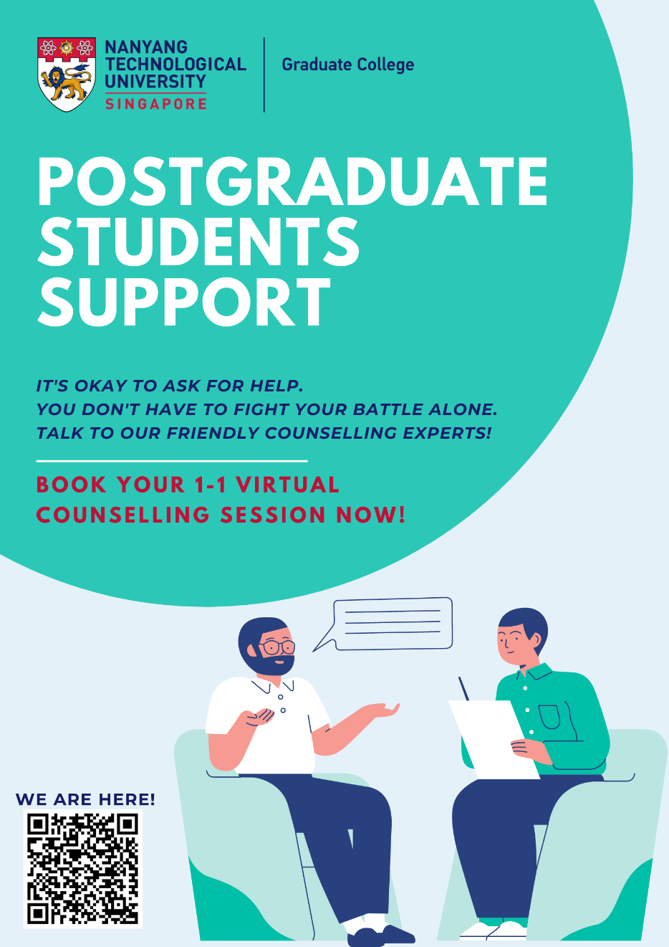
Registration call:
1st Call on 30 October 2021- Partnering with Psych Connect Pte Ltd (closed)
2nd Call on 29 April 2021- Partnering with Singapore Counselling Centre (closed)
Current Call since 6 June 2021- Partnering with Psych Connect Pte Ltd (ongoing)

