UNIVERSITY TEACHING
FOR TEACHING ASSISTANTS
PROGRAMME

STUDENT MANUAL

Table of Contents
1. REGISTRATION 1
1.1. Phases 1
1.2. Procedure for Priority Students 1
1.3. Procedure for Non-Priority Students 1
2. CLASS ALLOCATION 2
3. EXEMPTIONS 2
3.1. Criteria for Exemption 2
3.2. Request for Exemption 3
4. ADD/ DROP 3
5. WITHDRAWALS 3
6. ATTENDANCE 4
6.1. Attendance Requirement 4
6.2. Leave of Absence 4
7. PUNCTUALITY 5
8. IN-CLASS QUIZZES 5
9. ASSIGNMENTS 5
9.1. Assignment Criteria and Standards 5
9.2. Assignment Submission 5
9.3. Late Submissions 6
9.4. Extenuating Circumstances 6
10. MICROTEACHING 6
10.1. Criteria 6
10.2. Leave of Absence 6
10.3. Microteaching Reassessment 7
11. ACADEMIC INTEGRITY 7
12. COURSE STRUCTURE AND REQUIREMENTS 7
12.1. The Basic Course 7
12.2. The Extended Course 8
12.3. Module Sequence 8
APPENDIX 1 – Exemption Request Form 9
APPENDIX 2 – Withdrawal Form 11

REGISTRATION

Phases
    - To facilitate more efficient and effective management of class schedules, a closed registration system will be used. The closed registration will occur in two phases as follows:
- Phase 1 is for priority students.
- Phase 2 will only be opened for other students if there is still space available.

    - As a rule of thumb, only the following groups of students shall be deemed as priority:
- Confirmed PhD students
These are defined as students who have already passed QE and been confirmed as PhD candidates.

- Qualifying Examination students
These are defined as students who are expected to sit for their PhD qualifying examinations within nine months from the start of the term.

    - All other students who wish to be put on the priority list will need to put up a sufficiently strong case (backed by documentary evidence) for the request to be considered. CTLP’s decision on the request is final.

Procedure for Priority Students
    - View the TA programme schedule that is emailed to you prior to applying for priority registration.

    - Fill out the online registration form on the HWG702 Course Site found on NTULearn within the timeframe given.

    - After the registration closes, CTLP will review all the applications and allocate students to the various groups in a manner that maximises diversity.

    - Schools will notify students who have been unsuccessful at requesting for priority registration.

Procedure for Non-Priority Students
    - Non-priority students interested in taking up the course can register their interest with their schools.

    - Schools will compile these requests and submit them to CTLP for consideration.

    - Subject to seat availability after priority students have been allocated, CTLP will allocate places on a first-come-first-served basis.

    - CTLP will notify students of the status of each request via their respective schools.

CLASS ALLOCATION
  - Students are to ensure that they are able to attend all classes for all groups selected. This is because to ensure a good mix of students from diverse backgrounds (eg: gender, nationality, course of study etc…) within each group, CTLP will allocate students to any one of the preferred groups.

  - In the event of unusually high demand for certain groups, students will be asked to reselect their preferred groups. This is usually decided based on disciplines.

For example: If there are too many students from school X requesting to enroll in Group C, some of these students from school X will be asked to select another group.

EXEMPTIONS

Criteria for Exemption
    - As this is a formal course on higher education pedagogy, previous teaching experience alone is not regarded as sufficient grounds for exemption.
    - Exemptions will only be considered for HWG702 on the following grounds:
- Where the student can furnish documentary evidence that he/she has successfully completed an equivalent course in university teaching at another university or equivalent institution.
- Where the student can furnish documentary evidence that he/she has completed other courses that involve pedagogical training (such as from a recognised Institute of Education). This may include diplomas, masters, or other degrees specifically in higher education teaching and learning.
    - Notwithstanding the completion of pedagogical training from a recognised institution, each application for exemption will still be assessed for their relevance to teaching and learning at higher education.

Request for Exemption
    - Students who wish to be exempted from the course will have to complete the Exemption Request Form (Refer Appendix 1) and submit it to their schools for endorsement by the Head/ Dean/ Director of the school.

    - The Exemption Request Form is available at:
https://www.ntu.edu.sg/education/teaching-learning/courses-and-workshops/teaching-assistant-programme/programme-policy

    - The respective schools are to submit the completed form to CTLP within 3 working days of receiving the Exemption Request Form from the student.

    - After determining the validity of the request, CTLP will endorse the exemption request and submit a scanned copy of the form to OAS and the respective school within 3 working days of receiving the form from the school.
Note: Any exemption requests without sufficient supporting documentary evidence will be rejected and any subsequent resubmission (if received after the add/ drop period) will be deemed as a withdrawal.

    - Exemption requests received after the add/ drop period will be deemed as a withdrawal. As such, a “W” will be reflected on the transcript.

ADD/ DROP
  - Students will be allowed to add/ drop/ change classes during the add/ drop period. Students wishing to drop classes during the add/drop period are to send a request to TAP@ntu.edu.sg.

  - In the event that registered students wish to change groups during the add/ drop period, they will have to find other students willing to swap groups with them. Students unable to find someone to swap groups with them will either have to remain with the groups they have registered for, drop the course (during the add/drop period) or withdraw from the course (after the add/drop period).

WITHDRAWALS
  - After the add/ drop period, students who wish to withdraw will have to complete the Withdrawal Request Form (Refer to Appendix 2) and submit it to their schools for endorsement by the Head/ Dean/ Director of the school.

  - The respective schools are to submit the completed form to CTLP within 3 working days of receiving the Withdrawal Request Form from the student.

  - After determining the validity of the request, CTLP will endorse the withdrawal request and submit a scanned copy of the form to OAS and the respective school within 3 working days of receiving the form from the school.

  - Upon receiving confirmation from OAS that the student withdrawal request has been approved by OAS, CTLP will update the student database within 3 working days.

  - Students who withdraw from the course (within the time-frame specified by the Graduate Studies Office) will have a “W” reflected on their transcript. Please check with your respective schools on the cut-off date for withdrawals.

  - The Withdrawal Request Form is available at:
https://www.ntu.edu.sg/education/teaching-learning/courses-and-workshops/teaching-assistant-programme/programme-policy

ATTENDANCE

Attendance Requirement
    - Students are required to achieve 100% attendance.

Leave of Absence
    - In the event a student is absent due to medical reasons, the student is to:
- Notify the administrator immediately via email at TAP@ntu.edu.sg
- Submit the original Medical Certificate (issued in Singapore by a medical practitioner registered with the Singapore Medical Association) to the administrator within 1 working day of the expiry of the medical certificate.
- Attend the assigned replacement class (subject to availability).

    - In the event of an unforeseen situation (e.g. last minute official travel, passing of an immediate family member etc…), the student is to:
  - Notify the administrator immediately (i.e. upon receiving notification of the unforeseen situation) via email at TAP@ntu.edu.sg
  - Submit supporting documents, such as the flight confirmation, supporting letter/email from the school, death certificate etc
  - Attend the assigned replacement class (subject to availability).

Note:
* Personal trips (eg: holiday, having to attend a wedding) are not deemed as unforeseen situations.
* Immediate family members refer only to parents, spouse, siblings and children.

    - Upon receiving the supporting documents, the administrator is to determine the validity of the request for a replacement class, allocate the student to the replacement class (if request is valid) and notify the student within 1 working day of receiving the documents.

    - In the event that no replacement classes are available, the student is responsible for initiating the withdrawal process (Refer to clause 5 above).

PUNCTUALITY
  - Students are expected to be punctual for all classes.

  - Those who are late for 30 minutes or more will be deemed as absent and will not be able to sign in the attendance register. This will result in a Fail for the course because attendance requirements are not met.

IN-CLASS QUIZZES
  - For certain modules, there will be in-class quizzes on the pre-reading start of the lesson.

  - While (for attendance purposes) there is a grace period of 30 minutes, students who miss a quiz because they are late for class will be given a zero mark for that quiz. No replacement quiz will be given.

ASSIGNMENTS

Assignment Criteria and Standards
    - All assignment criteria and standards are made available to students on NTULearn. Students are to take responsibility in ensuring that their submissions meet these criteria and standards.

    - Failure to meet the assignment criteria or standards will result in a fail grade.

Assignment Submission
    - All students are to submit assignments on time. As this is a pass/ fail course, late submissions will not be marked and students will be deemed to have failed the assignment. Except for extenuating circumstances (Refer to clause 9.4), late submissions will be entertained.

    - All assignments are to be submitted via Turnitin. Assignments will be marked and comments can be viewed within 2 weeks of the submission date.

    - In the unlikely event that the student is unable to submit the assignment via Turn It In due to technical problems, the assignment is to be sent to TAP@ntu.edu.sg by the submission deadline. Late submissions will not be marked and students will be deemed to have failed the assignment.

Late Submissions
    - Since this course is graded on a pass/ fail basis, all late submissions would automatically receive a fail grade.

Extenuating Circumstances
    - Except for extenuating circumstances, no late submissions will be accepted.
- For the purposes of assessment submission, extenuating circumstances are more narrowly defined than for the Attendance Policy. Here, extenuating circumstances only include hospitalization leave which covers the submission due date, or the passing away of an immediate family member. (i.e. parents, siblings, spouse and children)

- Documentary evidence must be provided for submission dateline extensions to be granted.

MICROTEACHING

Criteria
    - All microteaching criteria and standards are made available to students on NTULearn. Students are to take responsibility in ensuring that the conduct of their microteaching session meets these criteria and standards.

    - Failure to meet the criteria or standards will generally result in a fail grade.

Leave of Absence
    - Except for extenuating circumstances, students who are absent from the microteaching session will be deemed to have failed.

    - For the purposes of the microteaching session, extenuating circumstances only include hospitalization leave which covers the microteaching session, or the passing away of an immediate family member. (i.e. parents, siblings, spouse and children)

    - Documentary evidence must be provided for an assessment date to be rescheduled.

    - For the rescheduled microteaching assessment, a fail grade will be awarded for:
- Failure to attend the rescheduled assessment (under any circumstances); OR
- Failure to meet the minimum passing criteria/ standards. No reassessment will be scheduled.

Microteaching Reassessment
    - At the discretion of the microteaching assessor, students who fail to satisfactorily meet the microteaching requirements may be granted one (1) reassessment opportunity.

    - For the microteaching reassessment, a fail grade will be awarded for:
- Failure to attend the reassessment (under any circumstances); OR
- Failure to meet the minimum criteria and standards.

ACADEMIC INTEGRITY
  - All Academic Integrity issues will be dealt with in accordance with University policy. Please refer to the NTU Academic Integrity webpage for more information.

COURSE STRUCTURE AND REQUIREMENTS

The Basic Course
    - The Basic Course is mandatory.

    - The Basic Course consists of 5 core modules.

    - To pass the Basic Course, students must:
  - attain 100% attendance for all 5 core modules; and
  - pass the written assessments of the core modules; and
  - attain any one of the following grades for the microteaching session:
    - Pass – Not Recommended to Teach; OR
    - Pass – Recommended to Teach

    - Students who pass the Basic Course will be deemed to have satisfied the HWG702 course requirement for QE qualification. As such:
- students will qualify for the stipend increase; and
- at the discretion of their schools, students may be assigned classes to teach.

    - Students who complete only the Basic Course will not be awarded the University Teaching for Teaching Assistants Certificate. To be awarded the certificate, students must successfully meet the requirements of the Extended Course.

The Extended Course
    - The Extended Course is optional. Only students who wish to be awarded the University Teaching for Teaching Assistants Certificate or intend to become faculty members in the future need to take this course.

    - The Extended Course consists of:
- the 5 core modules of the Basic Course; and
- 3 elective modules.

    - To be awarded the University Teaching for Teaching Assistants Certificate, students must:
  - meet the requirements of the Basic Course as defined above; and
  - attain a “Pass - Recommended to Teach” grade for the microteaching session; and
  - successfully complete the 3 elective modules.

Module Sequence
    - As each module builds on the learning of the previous module, modules must be taken in sequence. Students missing one module will not be allowed to attend subsequent modules and will have to withdraw from the course by submitting a withdrawal form.

    - Failure to submit the withdrawal form by the timeframe specified by the Graduate Studies Office will result in a fail grade. Please check with your respective schools on the cut-off date for withdrawals.

APPENDIX 1 – Exemption Request Form
(Available at: https://www.ntu.edu.sg/education/teaching-learning/courses-and-workshops/teaching-assistant-programme/programme-policy)

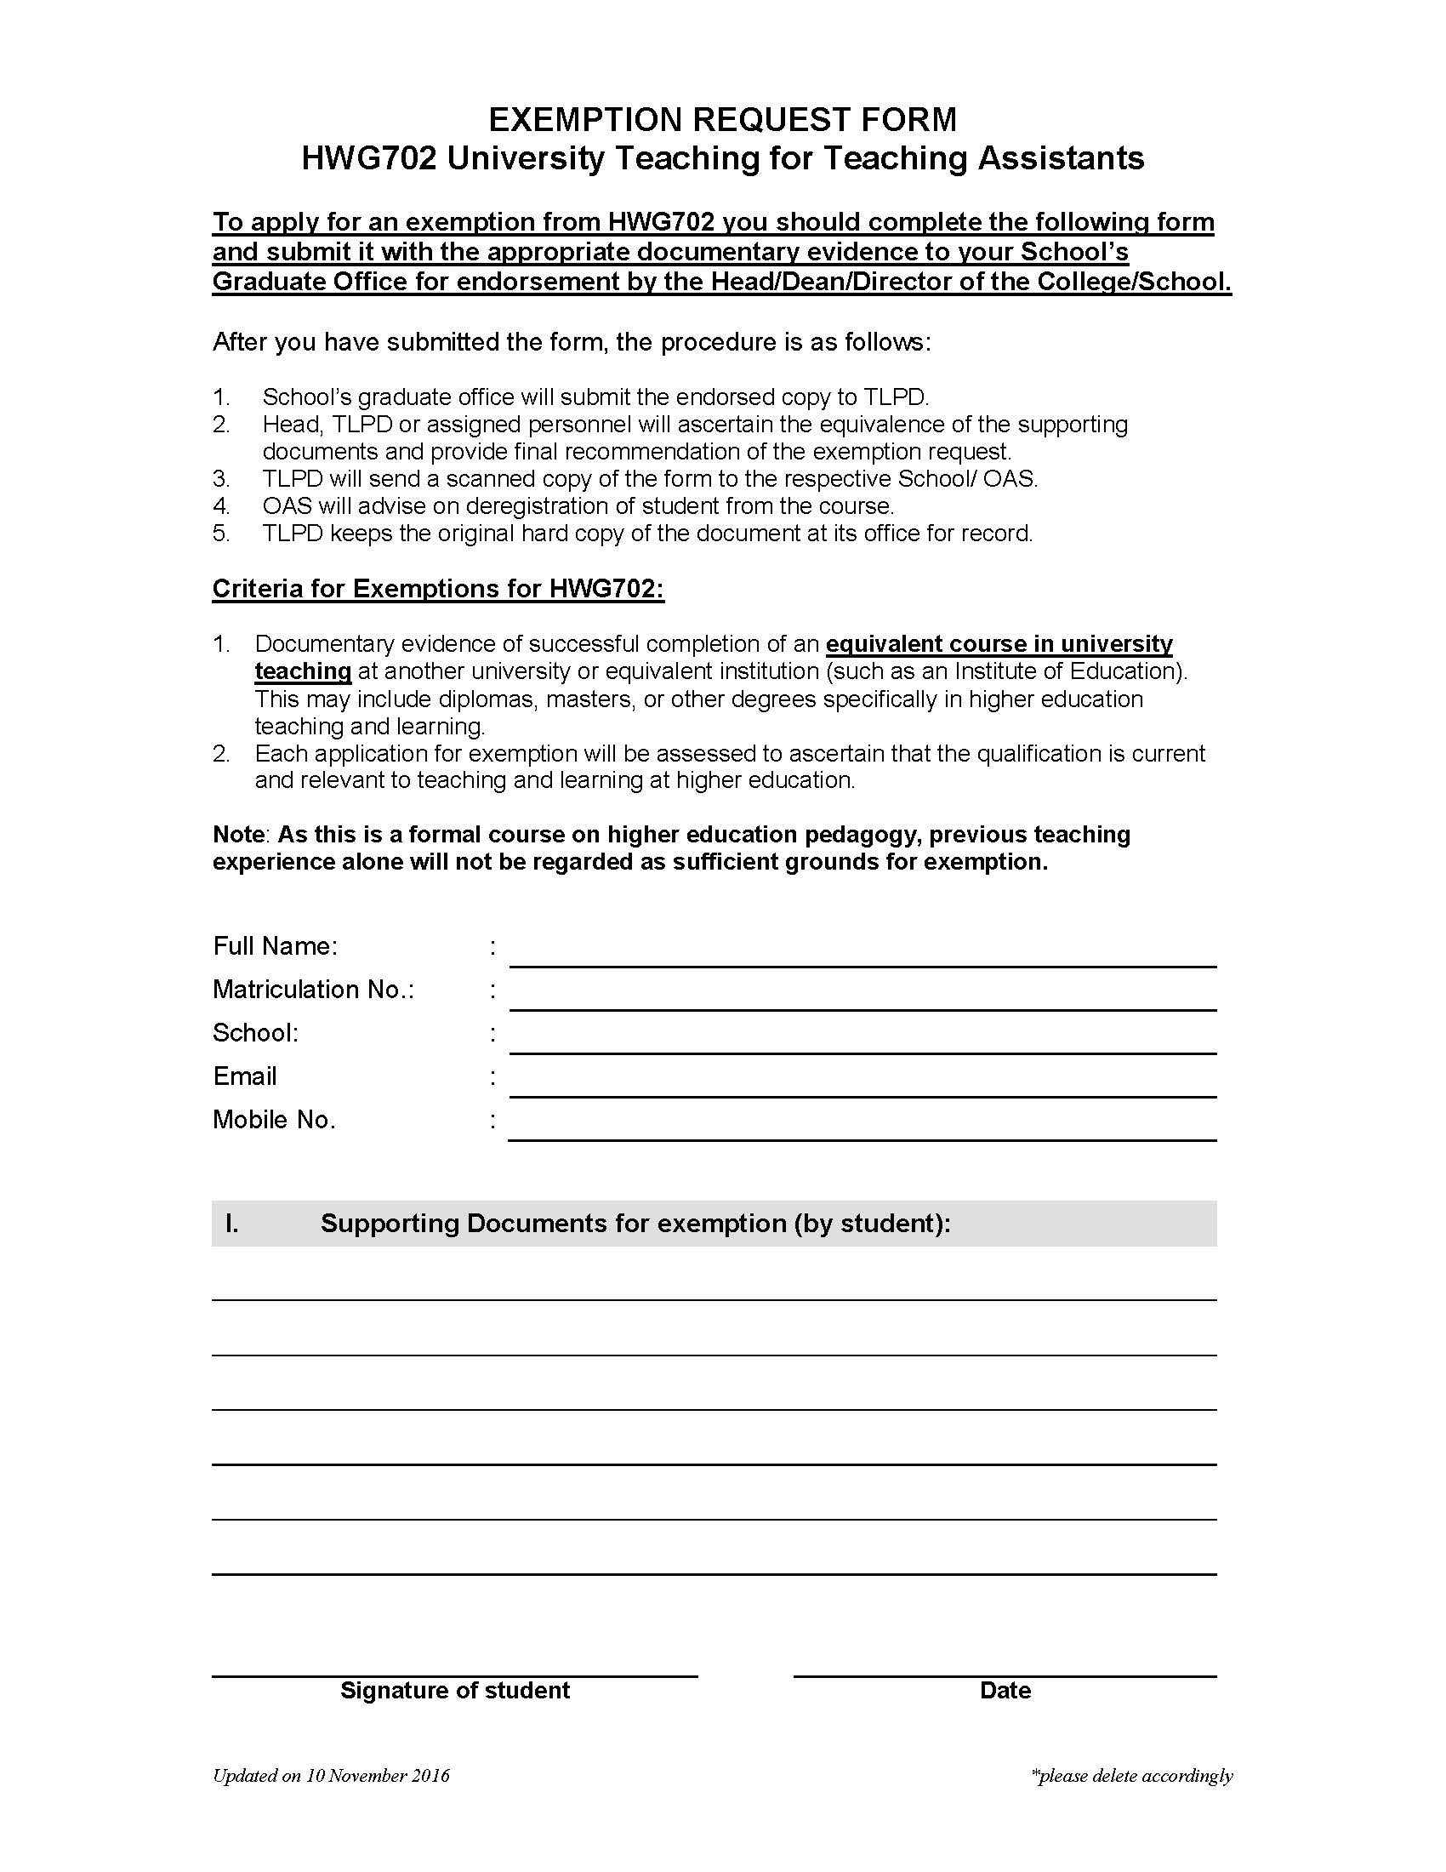

APPENDIX 1 (cont’d)

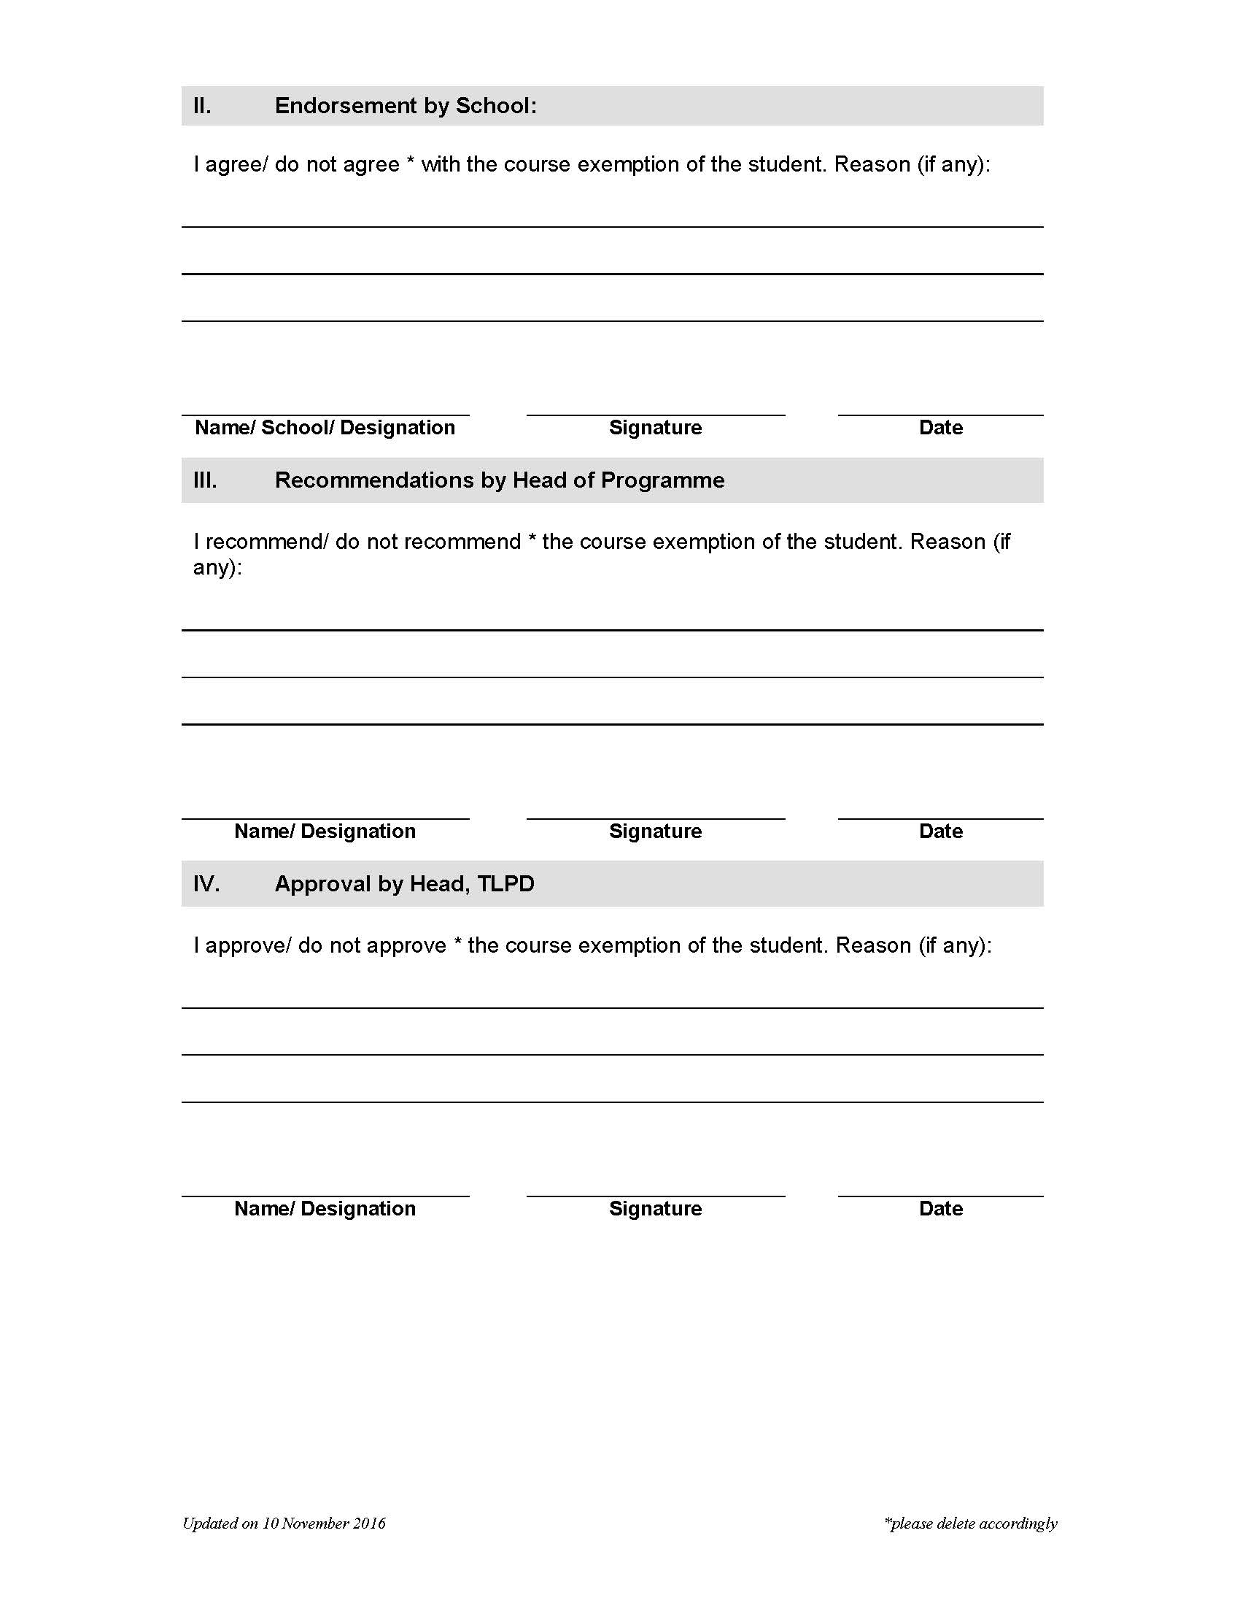

APPENDIX 2 – Withdrawal Form
(Available at: https://www.ntu.edu.sg/education/teaching-learning/courses-and-workshops/teaching-assistant-programme/programme-policy)
